Minnesota Utility 2020 CIP Reporting Instructions for Cooperatives and Municipal Utilities
Contents
Getting Started 3
Launching ESPReporting 3
General Information About Entering Data 4
Updating Organization Details 5
Updating Program Designs 5
Editing Existing Program Designs 6
Creating New Program Designs 8
Reporting Sales Data 9
Entering 2019 Total Sales Data 9
Entering Data for CIP-Exempt Customers 9
Reporting 2019 CIP Results and 11
2021 Budgets/Goals 11
General Information about Entering Numerical Program Data 12
Utility Metrics 13
Utility Cost Components 14
Program Participants 14
% of Spending by Customer Segments 14
Low income Participation 15
Energy Savings 16
Entering Delivered Fuel Savings 17
Electric Utility Infrastructure and Carry Forward Savings 17
Download a Draft Compliance Review Letter 18
Downloading a Draft Compliance Review Letter 18
Final Compliance Review Letters 20
Exempt Utilities 21
Exempt Utilities Reporting Independently 21
Exempt Utilities Reporting as Members of Aggregator Organizations 22
Submitting Data 23
Getting Help 23
Appendix 24

Getting Started
Reporting year 2020 for the Conservation Improvement Program (CIP) covers 2019 results and 2021 plans. CIP Reporting to the Minnesota Department of Commerce (Department) is conducted through the ESPReporting tool developed by Energy Platforms, LLC. The deadline for entering this information is June 1, 2020.

Launching ESPReporting

- Point your browser at www.energyplatforms.com.
  - Note: ESPReporting requires the use of the Microsoft Silverlight plug-in and, as a result, is only supported in Internet Explorer. It is not currently supported in other browsers such as Google Chrome or Microsoft Edge. You can download Silverlight for free here.
- Click Launch ESPReporting in the upper right portion of the window.

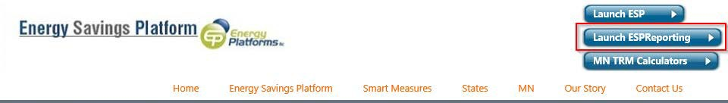

- ESPReporting will launch in a new browser window. You may need to enable popups in your browser.
- Enter your credentials (email address and password).
  - If you have forgotten your password, click on “Email change password instructions now.”
After logging in to ESP, you will see a My View section at the top of the Navigation Tree on the left. The My View branch contains all the areas in ESPReporting that are specific to your organization.
Data Entry is selected in the Navigation Tree by default as shown below.
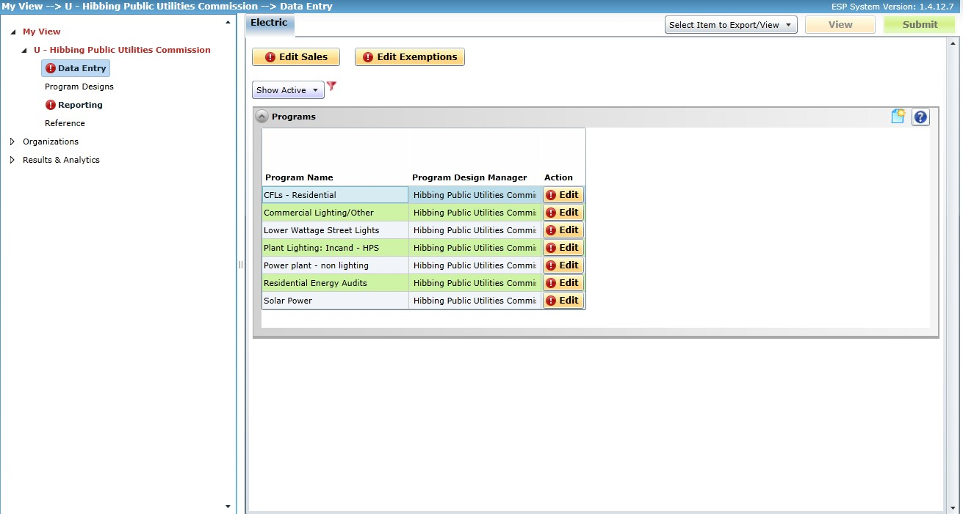

General Information About Entering Data
- Fields that are white are editable. Fields that are grey are not editable.
- Fields outlined in red indicate where you are expected to enter data for this reporting period. As you complete your data entry, the red will vanish.
- The information may be saved within the different editor forms throughout ESPReporting even if there is red in one or more fields.
  - The Save button becomes available when any data in an editor form is changed.
- The Submit button will become available when information has been entered in all the fields outlined in red.
  - Click Submit when you are done entering data. The Submit button will change to Reopen. If you need to edit data and ESPReporting is open for editing, click Reopen, edit the data, and click Submit. Once ESPReporting is closed for editing, the Reopen button is disabled.
  - The availability of the Submit button indicates that you have entered data in all the fields that were outlined in red.
- Note that information can be copied and pasted within ESPReporting or from another application using Ctrl-c and Ctrl-v, respectively.

Updating Organization Details
After logging into ESPReporting, review your organization details. It is important to keep this information up-to-date as it is used to contact your organization about CIP related matters.
Select the name of your organization under My View in the Navigation Tree on the left. If any changes are needed, click Edit. Make any changes that are needed and click Save.
Note: Aggregator organization information includes a list of member organizations.
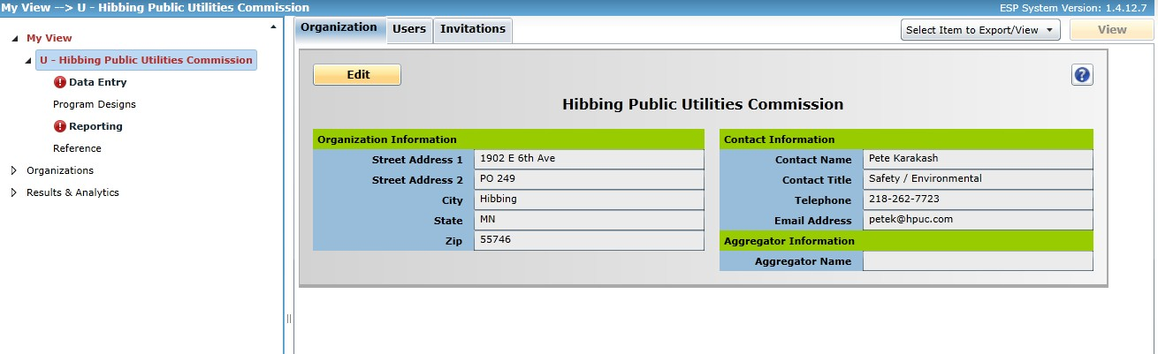

Updating Program Designs
Note to aggregator organizations and members: In most cases, the aggregator organization “owns” the Program Designs that are used by its members. However, some member utilities may own certain Program Designs. Please coordinate with your aggregator organization/member(s) as to who will be responsible for updating each Program Design.
Select Program Designs under My View in the Navigation Tree on the left.
A list of active Program Designs is shown as in the screenshot below. This view can be changed to Show All using the drop-down in the upper left, which will show active and inactive programs.
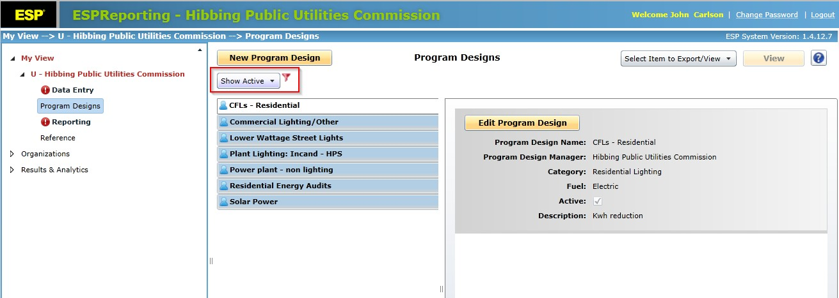

Editing Existing Program Designs
- Select a Program Design and click Edit Program Design to bring up the Program Design Editor, as shown below.
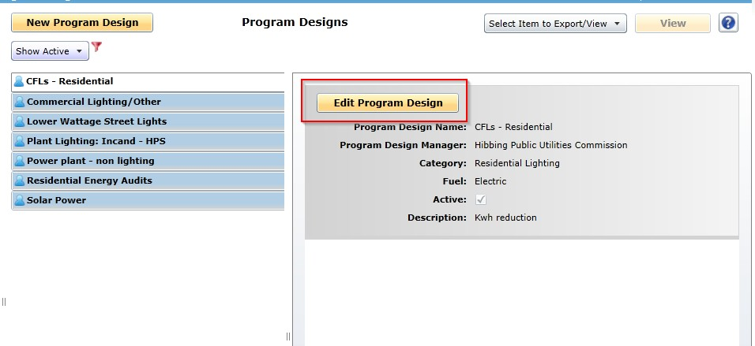
- To reduce workload, the 2020 Plan information for each Program Design has been copied to 2021. Please review each Program Design and edit as necessary to reflect any changes planned for 2021.
- The Active checkbox near the top of the Program Design Editor allows a user to set the default state of the program in 2019 and 2021. If unchecked, the Program Design is set to be inactive in 2019 and 2021, and it will not appear in the default list of programs in the Reporting or Data Entry areas. We recommend that users, especially aggregator organizations, review the Active checkbox setting for all Program Designs before proceeding with reporting numerical program data. Click Save after editing a Program Design.

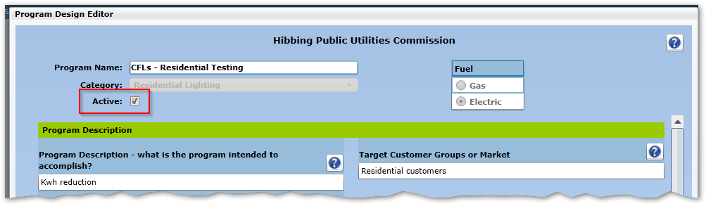

- Add any information about changes to the program under each annual section (e.g. 2021 Plan) as appropriate. While all programs should have some basic information in the “Program Description” section, this is especially important for the following categories:
  - Other – Direct
  - Other – Indirect
  - Specialty Non-Residential
  - Specialty Low Income
  - Specialty Residential

Creating New Program Designs
- If you are planning to run a new program in 2021 or need to report on a program in 2019 that does not have an existing Program Design, you will need to create a new Program Design.
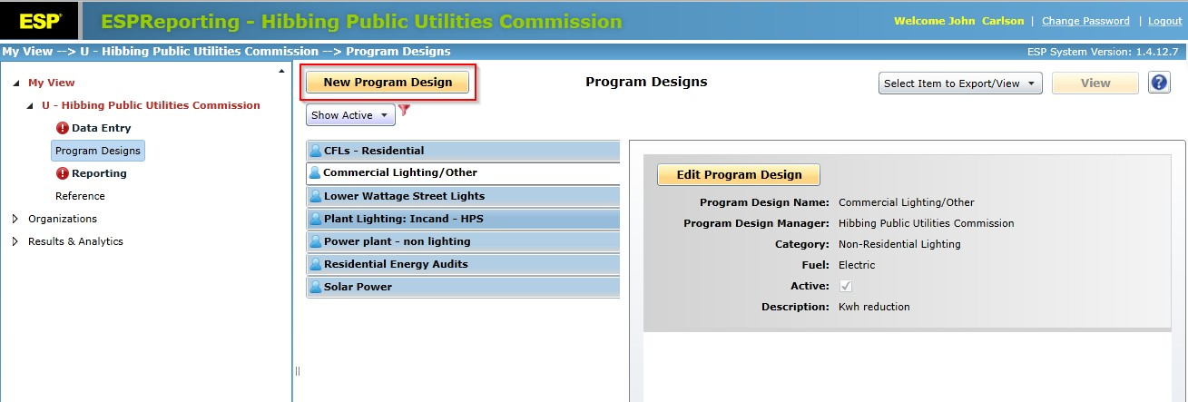
- Click the New Program Design button to open the Program Design Editor.

- Enter a name for the program in Program Name.
- Choose a Program Category from the Category drop-down list.
  - There is a list of Program Category descriptions in Table 2 of the Appendix at the end of this document.
- Combined electric and gas programs must have separate Program Designs for electric and gas.
- Fill out the fields under Program Description, 2021 Plan, 2020 Plan, and 2019 Plan. (Enter “N/A” in a field if the program was not active that year.) The boxes automatically expand as needed. Click Save when finished.
Note to aggregator organizations: The Program Design Editor has a list of your members near the bottom. Use this to select which members are allowed to use the Program Design.

Reporting Sales Data
Select Data Entry in the Navigation Tree.

Entering 2019 Total Sales Data
- Click Edit Sales to open the Sales Editor, shown below.
- Enter customer count, kWh or MCF sales, and gross operating revenue (GOR) by category (residential, commercial, industrial, farm and other) for 2019.
  - Enter the total amount. Do not subtract the sales or revenue of CIP-exempt customers.
- Click Save when done.

Entering Data for CIP-Exempt Customers
- Minn. Stat. § 216B.241 subd. 1a(b) allows the owner of a large customer facility to petition the Department to exempt utilities serving their facility from the CIP investment and expenditure requirements attributable to the facility. In these cases, utilities are no longer able to charge CIP fees to those exempt customers and the exempt customers cannot participate in utility CIP programs. (CIP-exempt customers are not customers that have IRS tax exempt status.)
- A current list of CIP-exempt customers is included Table 1 of the Appendix at the end of this document. If you are not sure whether your utility has any exempt customers, please refer to this list.
- Only utilities with CIP-exempt customers will have access to the Exemption Editor.
- Click Edit Exemptions to open the Exemption Editor, shown below.
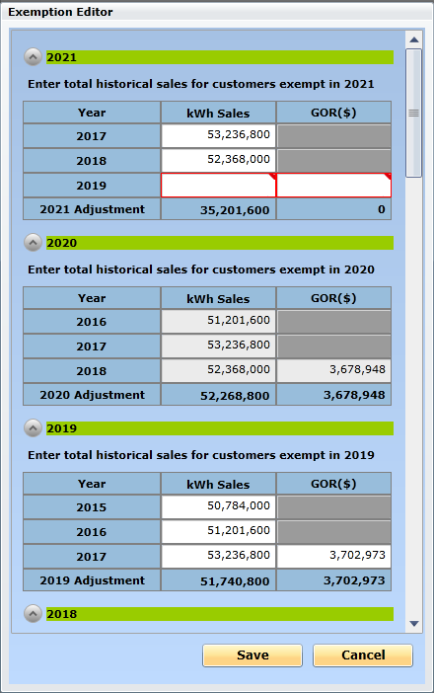

- Under the program year 2021 section, enter aggregate sales and GOR for 2019 for current CIP-exempt customer(s). Amounts associated with prior years has been pre-populated.
- Click Save when finished.

Reporting 2019 CIP Results and

2021 Budgets/Goals
Select Data Entry in the Navigation Tree.
There is a filter just above the list that will be set to a default of Active programs. This filter can be changed to show all programs.
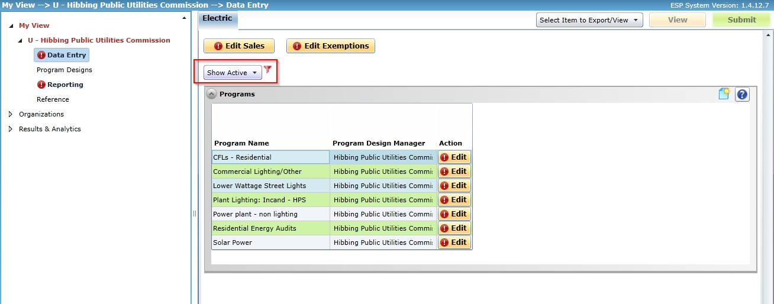

General Information about Entering Numerical Program Data
- Click the Edit button in each row to bring up the Program Reporting Editor for that program. An example is shown below.
- You will be reporting 2019 Actual and 2021 Plan data this year.
  - Note: if you are unsure of your 2021 minimum energy savings goals and budget or would like to verify that the data you plan to enter will meet the compliance review, you can generate a draft compliance review letter prior to entering data and make any adjustments as necessary. See the section towards the end of these instructions titled “Download a Draft Compliance Review Letter”.
- The Active checkbox is selected by default under 2019 and 2021. Uncheck the box if the program was not/will not be offered in a given year. If a program was offered in 2019 but there was no participation, no spending, and no savings then enter zeros for the all fields.
- Below the Active checkbox is a button labeled Narrative to allow you to enter a narrative description of the program activity in that year. (For example, you can use this area to explain why very low or very high savings were achieved for a particular year.)
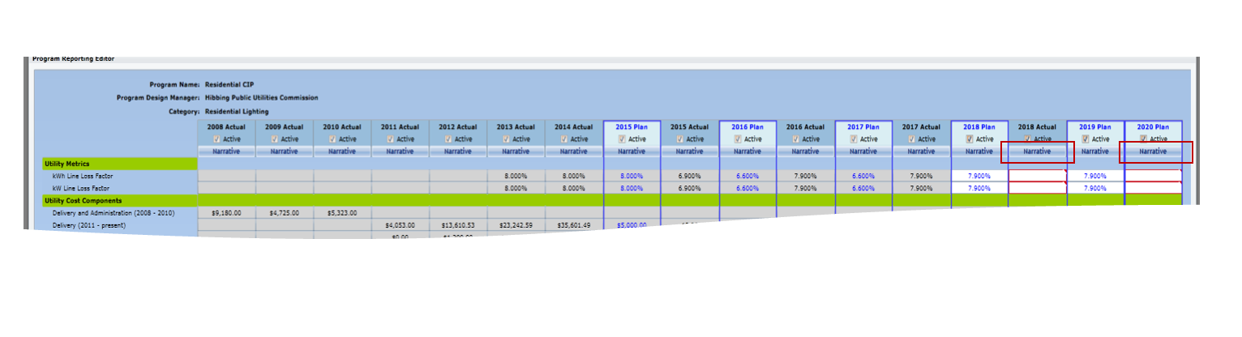

Utility Metrics
- For electric programs in all categories except Electric Utility Infrastructure, kWh and kW line loss factors must be entered. This enables the software to automatically calculate savings at the generator from the meter-level savings that are entered in Program Reporting Editors. (Savings at the generator are usually 5-10% higher than at the meter, depending on the utility.)
  - The following default line loss factors for kWh and kW savings for 2019 may be used by organizations that have not derived their own line loss factors. These default line loss factors were derived from EIA-861 data reported by Minnesota utilities.
    - Coops: 8.8%
    - Munis: 7.6%
  - For Electric Utility Infrastructure programs, the editor is designed so that savings at the generator must be entered directly.

Utility Cost Components
- Enter the amount spent for each budget category as appropriate according to your records.
- Use the following guidelines to help you determine how to report spending on different cost components.

Cost Category | Definition
Administration Cost | Expenses incurred in controlling and directing a program, but not directly identifiable with Delivery, EM&V, Advertising & Promotion or Incentives.
Delivery Cost | Total cost incurred by the program directly attributable to delivering the product or service that causes energy savings.
Evaluation, Measurement & Verification | Expenses of activities outside of the program delivery to evaluate process or impact, measure results, or verify that energy savings measures were actually delivered.
Advertising and Promotion | Money spent on marketing a program to a specific group of energy consumers.
Incentives | Total amount paid directly to energy consumers or third parties to incent them to take a specific action to save energy. For programs where the customer is given a rebate for purchasing and installing equipment, enter the amount paid to customers for rebates in the Incentives category. For other types of programs, enter the monetary value of the incentive given to the participant (e.g. cost of an energy assessment).
Other | Any expense that does not fall into the other cost categories.

Program Participants
- Enter the appropriate amount according to your records.

% of Spending by Customer Segments
- Enter the appropriate amounts according to your records.

Low income Participation
- Low income Participation % and Budget % are fixed at 100% or 0% or are user-specified depending on the program category.
  - For programs with the following program categories, the fields are fixed at 100%:
    - Indirect Low Income
    - Low Income Weatherization
    - Specialty Low Income
  - All program categories in the Commercial/Industrial/Agricultural (CIA) market segment except program category Multifamily are fixed at 0%.
  - All programs in the Residential market segment and in the program category Multifamily are user-specified.
    - Where the figures are user-specified, actual low income participation data may be entered according to your records, if available, or estimated low income participation data from 2010 US Census data may be used. Table 3 in the Appendix at the end of this document provides percentages of low income household by county. If your service area covers multiple counties, please use a weighted average of the low income percentages in each county.
  - Refer to Table 2 of the Appendix at the end of this document for a list of program categories and corresponding market segments.

Energy Savings
- Enter energy savings as recorded at the customer meter. Savings at the generator will be automatically calculated by the software based on the values entered for energy savings at the customer meter and line losses.
- Energy savings must follow the methods provided in the Minnesota Technical Reference Manual (TRM) unless otherwise approved by the Department.
  - Version 2.2 should be used for 2019.
  - Version 3.1 should be used for 2021.
  - A Summary of Changes from TRM version 2.1 to 3.0 is provided at the CIP TRM webpage.
  - Please note that each TRM has a version number, and each TRM measure has a version number. For example, the screenshot below is of the beginning of measure version 1.0 of the VSD Milk Pump measure in TRM version 3.0. (This measure was added in TRM version 2.1 and there were no changes to this measure between TRM version 2.1 and 3.0.)

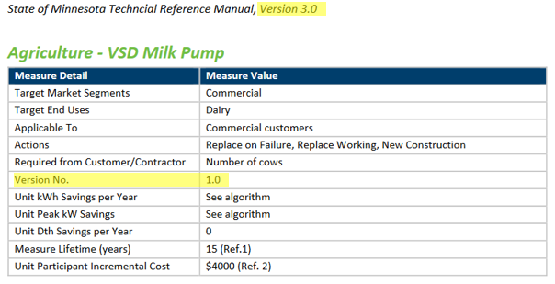

Entering Delivered Fuel Savings
- Electric utilities may count equivalent kWh savings from heating fuel (fuel oil no. 2, liquid propane gas (LPG), and natural gas) savings achieved in low income programs under certain conditions. Refer to the Department’s guidance on this matter, available here.
  - Natural gas savings can only be claimed if the customer is served by a municipal gas utility that is exempt from CIP requirements.
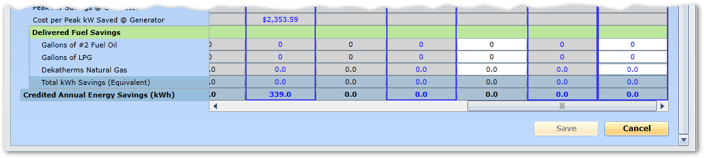
- The Program Reporting Editor for low income programs for electric utilities will include fields where gallons of fuel oil no. 2, gallons of LPG, and dekatherms of natural gas saved can be entered, as shown below. The software will automatically calculate the equivalent kWh savings and total credited savings for the program.

Click Save to save the data and exit the Program Reporting Editor.

Electric Utility Infrastructure and Carry Forward Savings
The Department published a Decision on February 20, 2018 in docket 17-856 and on its website in the matter of Claiming Energy Savings through Electric Utility Infrastructure Improvements and the Carry Forward Provision. Utilities should refer to this document for details and instructions if applicable.
One change from past practices of note is that COUs need to notify the Department via email by June 1 in order to carry forward savings from previous year’s results. An example is provided in the document. The Department will review the eligibility of the proposed carry forward savings as part of the regular COU reporting/planning review process. The compliance letter will note the use of carry forward savings and the adjustment towards achieving the energy savings goal. However, the Energy Savings Platform will reflect actual performance in order to accurately record and track actual annual statewide performance.

Download a Draft Compliance Review Letter
While it is possible to submit a plan that does not meet all the compliance points, the Department suggests that you review your draft compliance review letter and make appropriate adjustments in order to submit a plan that meets all the compliance points. If you find any conclusions that you believe are in error, contact the Department.
If your compliance review letter says that any of the spending caps in 2019 or 2021 have been exceeded, you must edit your data in order to bring those into compliance. (For example, if the load management spending cap has been exceeded, you must remove the excess amount of spending from one or more of your load management programs.
Draft letters for aggregator organizations do not include CIP-exempt member utilities except those that are exempt and reporting voluntarily.

Downloading a Draft Compliance Review Letter
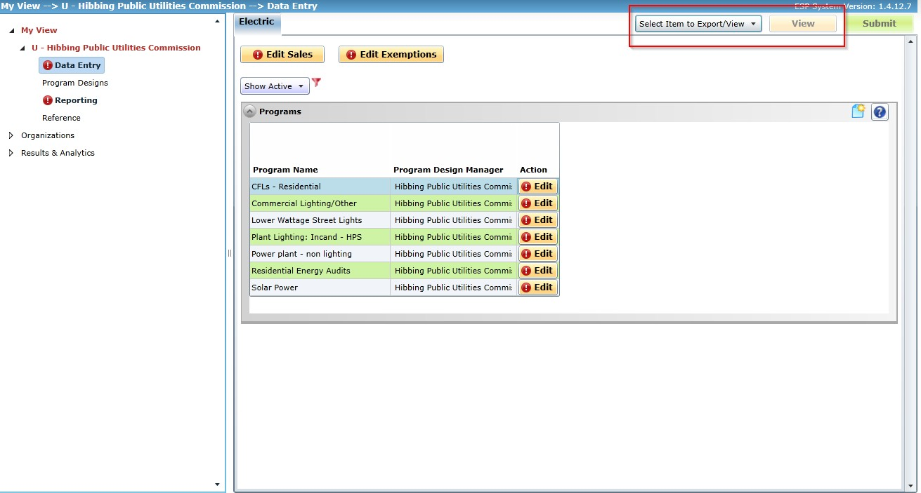
The letters are available from the drop-down menu in the upper right corner of each view in ESPReporting.

Click the drop-down menu and select DER Draft Letter. After making your selection, click View.
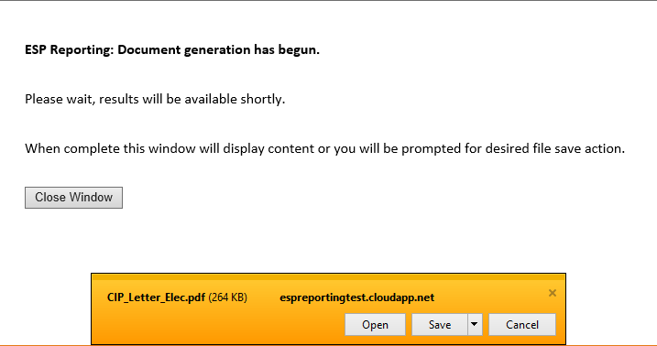
A second window will appear as the letter is being generated. Once the letter is ready for viewing an alert appears in the window. Click Open to view the letter.

The sample letter will have a “DRAFT” watermark.
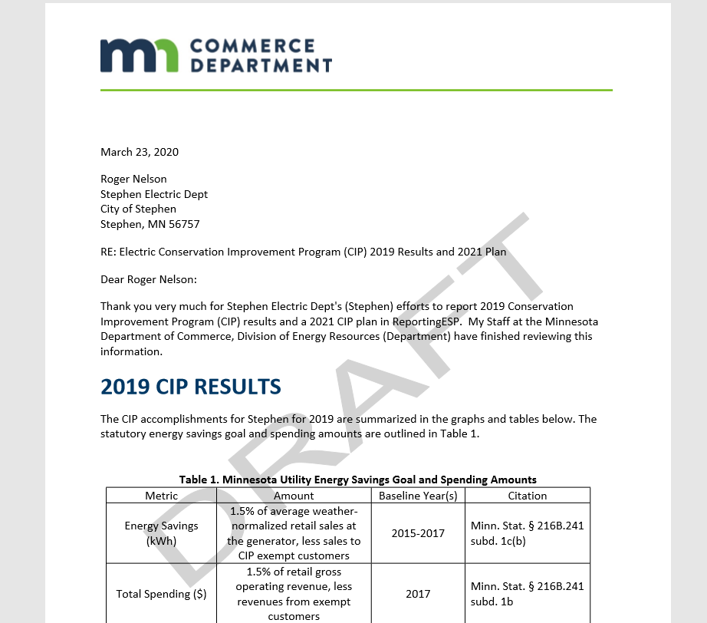

Final Compliance Review Letters
Department Staff review the draft letters generated in ESPReporting, adjust them as appropriate, and prepare a final version for the Deputy Commissioner’s review. Final letters are filed on eDockets, the electronic docketing system for the Department and the Public Utility Commission, at https://www.edockets.state.mn.us/EFiling/search.jsp.
2020 letters will be filed in docket 20-24. Utilities can check docket 20-24 at any time. Utilities can also subscribe to that docket and receive automatic notices when letters are posted there. Note that multiple letters are posted in a single submission to eDockets. Subscribers will receive an email for each submission. Subscribers should expect to receive about 6 emails.
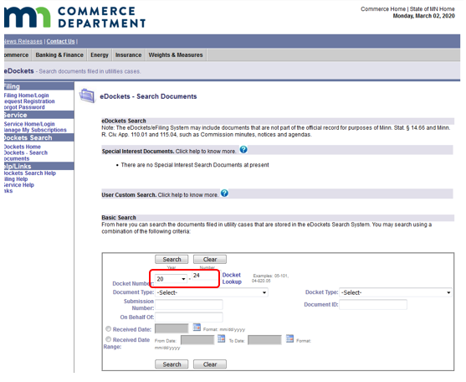

Exempt Utilities
The Department tracks utilities that are exempt from CIP according to the thresholds listed in Minnesota Statutes 216B.241 subd. 1b. (a) based annual data reporting required pursuant to MN Rules Chapter 7610.

Exempt Utilities Reporting Independently
Exempt utilities that desire to report in ESPReporting may do so. The software will not function any differently for these utilities.

Exempt Utilities Reporting as Members of Aggregator Organizations
The Department has communicated with aggregator organizations to confirm which member utilities are exempt and to identify which exempt member utilities are continuing to participate. This information is displayed in the organization details area for aggregator organizations in the list of member utilities. If any of this information needs to be changed, contact the Department.
- Utilities indicated as “Exempt” and not “Exempt Voluntarily Reporting” are not included in the compliance review letter for the aggregator organization.
  - Individual exempt utilities may report independently if they desire.
- Utilities indicated as “Exempt” and “Exempt Voluntarily Reporting” are included in the compliance review letter for the aggregator organization.

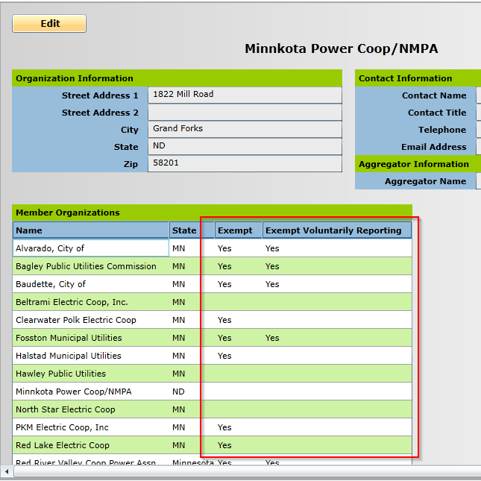

Submitting Data
When valid data has been entered in all required fields (i.e. there are no longer any fields outlined in red), the Submit button becomes active. Click Submit when all data entry is completed.
  - Any data entered will persist when you log off regardless of whether Submit is clicked.
  - Even if you press the Submit button, you can continue to edit data as long as ESPReporting is open for editing by clicking Reopen.
  - Clicking Submit simply indicates to the Department that you have completed the reporting process.

Getting Help
Energy Platforms and Department staff are happy to help with any questions regarding reporting.
For software questions or concerns, please contact the Energy Platforms help desk using the
Contact Us page at www.energyplatforms.com.
For deadline or policy-related questions and for questions regarding savings calculations, please contact Laura Silver or Anthony Fryer at the Minnesota Department of Commerce.
  - Laura.Silver@state.mn.us (651) 539-1873
  - Anthony.Fryer@state.mn.us (651) 539-1858

Thank you for helping us collect accurate CIP data in Minnesota!

Appendix
Table 1. CIP-Exempt Customers of Coops and Munis as of 2020
Utility | Business
Agrilite | Chippewa Valley Ethanol Company
BENCO | Corn Plus Cooperative
Brown County Rural Electric Association | Heartland Corn Products
Fairfax Public Utilities | Heartland Corn Products
Federated Rural Electric Association | Buffalo Lake Energy, LLC
 | Valero Renewable Fuels Company
Freeborn-Mower Cooperative Service | AGRA Resources Coop dba POET Biorefining Glenville
Marshall Municipal Utilities | Archer Daniels Midland
McLeod Coop Power | Heartland Corn Products
MiEnergy | Pro-Corn LLC dba POET Biorefining-Preston
Minnesota Valley Cooperative Light & Power Association | Granite Falls Energy, LLC
Nobles Electric Cooperative | Minnesota Soybean Processors
Redwood Electric Cooperative Association | Highwater Ethanol, LLC
South Central Electric Association | Northstar Ethanol, LLC dba POET Biorefining-Lake Crystal
Steele-Waseca Cooperative Electric | Al-Corn Clean Fuel Cooperative
Worthington Public Utilities | Swift Pork Company

Table 2. Program Category Descriptions
Category Name | Description | Market Segment
Agricultural Efficiency | Incentive and technical assistance programs for agricultural customers | Commercial/ Industrial/ Agricultural (CIA)
Appliance Harvesting | Removal and disabling or recycling of working refrigerators, freezers, and room A/Cs | Residential
Compressed Air | Compressed air system studies and incentives | CIA
Consumer Electronics / Plug Loads | Incentive programs for purchase of energy efficient computers, televisions, and other consumer electronics; installation of smart power strips, adjustment of computer power management settings, other activities related to plug loads | Residential
Distributed and Renewable Energy | Qualifying distributed and renewable energy projects | General/Other
Electric Utility Infrastructure Improvements | Improvements in generation, transmission, and distribution infrastructure resulting in lower losses. Also includes demand-side improvements to utility facilities and waste heat to electricity generation projects. | General/Other
ENERGY STAR Appliances | Incentive programs for purchase of ENERGY STAR-rated home appliances including clothes washers, dryers, refrigerators, and dishwashers | Residential
Food Service | Incentives and technical assistance for commercial cooking and other food preparation equipment | CIA
Gas Utility Biomethane Purchases | Natural gas utilities may purchase biomethane produced from anaerobic digestion of biomass, gasification of biomass, or other effective conversion process that is then cleaned to pipeline-quality standards and injected into the natural gas distribution system. | General/Other
General Marketing and Education | General CIP marketing expenses for promoting awareness of utility programs, conservation ethics, and energy savings opportunities; not intended to promote a particular incentive or program | General/Other
Indirect Low Income | Programs serving low income customers that do not result in direct energy savings. | Residential
Internal Training | Training of utility staff members on CIP-related topics | General/Other
Lamp Disposal and Recycling | Administration and materials related to proper management of spent lamps; spent lamp collection, disposal, and recycling savings | General/Other
Low Income Weatherization | Utility funding assistance for the federal Weatherization Assistance Program. Includes shell measures, lighting, and replacement of furnaces, boilers, and water heaters. Electric utilities may claim equivalent kWh savings for propane and fuel oil. | Residential
Market Research and Product Development | General market research and product development expenses | General/Other
Motors & Drives | Motor assessment studies, incentives for high efficiency motors and variable frequency drives | CIA
Multifamily Buildings | Programs intended to improve the energy efficiency of existing or new multifamily buildings | CIA
Non-Residential Behavioral/Operations | Programs that work with building occupants and operations staff to encourage energy conservation behaviors and efficient building systems operations | CIA
Non-Residential Building Energy Audits/ Analysis | Energy audits and analysis of commercial or institutional facilities | CIA
Non-Residential Building Envelope | Insulation, air sealing, windows and doors | CIA
Non-Residential Computer Efficiency and Plug Loads | Computer power management tools, manufacturer incentives, customer incentives for energy efficient computers and peripherals | CIA
Non-Residential Custom Efficiency | Building and process improvement projects that require custom engineering analysis | CIA
Non-Residential Heat Pumps | Incentive programs for purchase and installation of air source, ground source, and water source heat pumps | CIA
Non-Residential Lighting | Incentive programs for purchase and installation of energy efficient lighting | CIA
Non-Residential Load Management | Programs that are primarily intended to shift the timing of commercial energy usage to off-peak periods and achieve kW savings rather than kWh savings. Includes air-conditioner cycling, off-peak water heating and load control rates. | CIA
Non-Residential Refrigeration | Incentive programs for purchase and installation of efficient refrigeration equipment | CIA
Non-Residential Service Water Heating | High efficiency water heaters, pipe insulation, faucet aerators and other measures that reduce energy for hot water | CIA
Non-Residential Space Cooling (Non-Heat Pumps) | Incentive programs for purchase and installation of energy efficient chillers, rooftop units and other DX equipment | CIA
Non-Residential Space Heating (Non-Heat Pumps) | Incentive programs for purchase and installation of energy efficient boilers and furnaces. Includes boiler tune-ups and boiler add-ons such as turbulators, stack dampers, modulating burners, O2 trim, etc. | CIA
Non-Residential Whole Building - Non-Process Related | Programs that take a comprehensive approach to building energy use, addressing multiple building systems at once. Examples include recommissioning projects and operations & maintenance programs. | CIA
Other - Direct |  | General/Other
Other - Indirect |  | General/Other
Public Infrastructure | Installation of energy efficient public infrastructure including streetlights and traffic lights | CIA
Regulatory Charges | CIP-related utility assessments | General/Other
Residential Behavioral Change | Programs that use continuous or periodic feedback in the form of energy monitoring devices or home energy reports to influence customer behavior regarding home energy use | Residential
Residential Building Envelope | Insulation, air sealing, windows, and doors | Residential
Residential Domestic Hot Water | Incentives for purchase and installation of energy efficient water heaters; Other domestic hot water measures including pipe wrap, water heater blankets, low flow showerheads, and faucet aerators | Residential
Residential Energy Audits / Analysis | Energy audits and analysis intended to educate customers on energy savings opportunities in their homes | Residential
Residential Heat Pumps | Incentives for purchase and installation of air source heat pumps, ground source heat pumps, and mini- split ductless heat pumps; quality installation programs | Residential
Residential Lighting | Incentives for the purchase of energy efficient lighting products including compact fluorescent lamps, ENERGY STAR fixtures, LED technologies, etc. | Residential
Residential Load Management | Programs that are primarily intended to shift the timing of residential energy usage to off-peak periods and achieve kW savings rather than kWh savings. Includes air-conditioner cycling, off-peak water heating, and electric thermal storage technologies. | Residential
Residential Space Cooling (Non-Heat Pumps) | Incentives for purchase and installation of energy efficient central and room air-conditioners; quality installation programs | Residential
Residential Space Heating (non-Heat Pumps) | Incentives for purchase and installation of energy efficient furnaces and boilers; boiler tune-ups; furnace electronic commutating motors; energy and heat recovery ventilators | Residential
Specialty Low Income | Specialty direct-savings programs for low income customers | Residential
Specialty Non- Residential | Specialty commercial/industrial programs that do not fit into a standard category | CIA
Specialty Residential | Specialty programs that do not fit into standard residential program categories. Examples include direct install programs and community energy initiatives. | Residential
Vending Machine Efficiency | Incentives for purchase and installation of energy efficient vending machines and vending machine power management devices | CIA
Whole House | Programs that address the house as a system including building shell measures, appliances, and lighting. Includes programs for both new construction and existing housing. | Residential

Table 3. Percentage of Households with
Less Than 50% of State Median Income in 2010 by County
Aitkin | 34.7% | Isanti | 19.1% | Pipestone | 35.4%
Anoka | 15.5% | Itasca | 31.4% | Polk | 30.5%
Becker | 30.3% | Jackson | 27.8% | Pope | 27.8%
Beltrami | 34.8% | Kanabec | 27.2% | Ramsey | 26.7%
Benton | 26.8% | Kandiyohi | 27.8% | Red Lake | 28.4%
Big Stone | 34.0% | Kittson | 28.9% | Redwood | 32.2%
Blue Earth | 29.0% | Koochiching | 37.6% | Renville | 29.5%
Brown | 27.1% | Lac qui Parle | 27.9% | Rice | 22.0%
Carlton | 26.1% | Lake | 30.6% | Rock | 29.8%
Carver | 12.8% | Lake of the Woods | 27.2% | Roseau | 23.4%
Cass | 31.7% | Le Sueur | 20.4% | St. Louis | 32.7%
Chippewa | 30.6% | Lincoln | 31.3% | Scott | 10.8%
Chisago | 16.1% | Lyon | 29.9% | Sherburne | 14.9%
Clay | 28.9% | McLeod | 21.3% | Sibley | 24.7%
Clearwater | 36.0% | Mahnomen | 35.5% | Stearns | 25.9%
Cook | 28.0% | Marshall | 25.9% | Steele | 23.3%
Cottonwood | 33.0% | Martin | 31.2% | Stevens | 31.0%
Crow Wing | 30.5% | Meeker | 24.8% | Swift | 35.3%
Dakota | 14.5% | Mille Lacs | 30.8% | Todd | 32.2%
Dodge | 17.5% | Morrison | 29.6% | Traverse | 34.1%
Douglas | 29.8% | Mower | 31.5% | Wabasha | 26.1%
Faribault | 35.0% | Murray | 30.1% | Wadena | 41.4%
Fillmore | 29.6% | Nicollet | 20.7% | Waseca | 24.9%
Freeborn | 32.5% | Nobles | 33.9% | Washington | 13.0%
Goodhue | 24.6% | Norman | 34.0% | Watonwan | 29.7%
Grant | 33.2% | Olmsted | 19.1% | Wilkin | 23.6%
Hennepin | 22.5% | Otter Tail | 31.6% | Winona | 33.2%
Houston | 29.2% | Pennington | 32.7% | Wright | 15.9%
Hubbard | 30.4% | Pine | 30.6% | Yellow Medicine | 28.9%

